module siso(

input wire clk,

input wire reset,

input wire serial_in,

output wire serial_out

);

reg [3:0] shift_reg;

always @(posedge clk or posedge reset) begin

if (reset) begin

shift_reg <= 4'b0000;

end else begin

shift_reg <= {shift_reg[2:0], serial_in};

end

end

assign serial_out = shift_reg[3];

endmodule

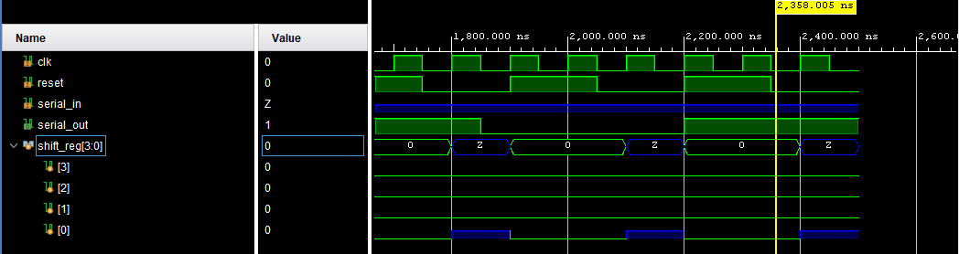

Test Bench:

module tb_siso_shift_register;

// Testbench signals

reg clk; // Clock signal

reg rst; // Reset signal

reg serial_in; // Serial input

wire serial_out; // Serial output

// Instantiate the SISO Shift Register

siso_shift_register uut (

.clk(clk),

.rst(rst),

.serial_in(serial_in),

.serial_out(serial_out)

);

// Clock generation

initial begin

clk = 0;

forever #5 clk = ~clk; // 10 time units clock period

end

// Test sequence

initial begin

// Initialize signals

rst = 1; // Activate reset

serial_in = 0;

#10; // Wait for some time

rst = 0; // Deactivate reset

// Apply serial input bits

serial_in = 1; #10; // Shift in 1

serial_in = 0; #10; // Shift in 0

serial_in = 1; #10; // Shift in 1

serial_in = 0; #10; // Shift in 0

serial_in = 1; #10; // Shift in 1

serial_in = 1; #10; // Shift in 1

serial_in = 0; #10; // Shift in 0

serial_in = 1; #10; // Shift in 1

// Final state check

#10; // Wait for one more clock cycle

$stop; // End simulation

end

endmodule